

MSc Data Science Project
7PAM2002
Department of Physics, Astronomy and Mathematics

Data Science FINAL PROJECT REPORT

Project Title:
Detecting Healthcare Provider Fraud Using Aggregated Claims Analysis and Machine Learning

Student Name and SRN:
Charan Sai Alluru 23096461

Supervisor: Pushp Raj Tiwari
Date Submitted: 22-04-2026
Word Count: 5208
GitHub repository link: https://github.com/Charanca24/Data-science-Project

DECLARATION STATEMENT

This report is submitted in partial fulfilment of the requirement for the degree of Master of Science in Data Science at the University of Hertfordshire.
I have read the detailed guidance to students on academic integrity, misconduct and plagiarism information at Assessment Offences and Academic Misconduct and understand the University process of dealing with suspected cases of academic misconduct and the possible penalties, which could include failing the project or course.
I certify that the work submitted is my own and that any material derived or quoted from published or unpublished work of other persons has been duly acknowledged. (Ref. UPR AS/C/6.1, section 7 and UPR AS/C/5, section 3.6)
I did not use human participants in my MSc Project.

I hereby give permission for the report to be made available on module websites provided the source is acknowledged.

Student Name printed: Charan Sai Alluru

Student Name signature: Charan Sai Alluru

Student SRN number:23096461

SCHOOL OF PHYSICS, ENGINEERING AND COMPUTER SCIENCE

Abstract
The healthcare system suffers from healthcare fraud which costs the system multiple billion dollars because it takes away essential resources that should be used to treat patients and redirects them to support criminal activities. My research study analyzes this systemic threat through the use of advanced machine learning methods which help identify fraudulent healthcare providers by analyzing combined claims information. I tested the Random Forest, XGBoost, and LightGBM algorithms on 5,410 records to determine their performance during the main test which required handling class imbalance. My first models achieved high accuracy results but I needed to improve their sensitivity which I accomplished through SMOTE which raised recall to 77.23% and Random Forest reached its best performance point. The SHAP analysis revealed that TotalReimbursement and TotalClaims serve as the main indicators for fraud detection. My explainable machine learning framework demonstrates robust detection abilities which maintain transparency to protect healthcare system integrity.
Contents
Abstract ii
1 Introduction 1
1.1 Overview 1
1.2 Current Market Practice 1
1.3 Problem Statement 1
1.4 Purpose and Aim 1
1.5 Objectives 1
1.6 Research Questions 2
1.7 Report’s Structure 2
2 Background 3
2.1 Overview 3
2.2 Review of Studies 3
2.3 Summarized Literature Review and Gap identified 4
3 Dataset 5
3.1 Dataset Source 5
3.2 Reason for Selecting the Dataset 5
3.3 Data Pre-processing 5
3.4 Exploratory Data Analysis (EDA) 6
3.4.1 Target Variable Distribution 6
3.4.2 Distribution of Claims 6
3.4.3 Correlation Heatmap 7
3.4.4 Feature Distribution Plot 8
4 Ethical Consideration 9
4.1 Overview 9
4.2 Data Privacy and GDPR 9
4.3 Ethical Approval 9
4.4 Permission and Licensing 9
4.5 Ethical Use 9
5 Methodology 10
5.1 Overview 10
5.2 Train-Test Split 10
5.3 Machine Learning Models 10
5.3.1 Preliminary Model Specification. 10
5.4 Handling Class Imbalance 10
5.5 Model Evaluation 11
5.6 Model Comparison 11
5.7 Cross-Validation 11
5.8 Explainable AI (SHAP) 12
5.9 Tools and Libraries 12
6 Results 13
6.1 Overview 13
6.2 Performance Before Balancing Strategies 13
6.3 Performance After Balancing Strategies (SMOTE) 14
6.4 Visualization of Models 15
6.5 Cross-Validation Results 16
6.6 Model Interpretability using XAI 16
6.7 Research Questions Addressed 18
6.8 Practical Applicability 18
7 Analysis and Discussion 19
7.1 Overview 19
7.2 Interpretation of Results 19
7.3 Effect of Class Imbalance and SMOTE. 19
7.4 Best Performing Model 20
7.5 Comparison with Literature 20
7.6 Importance and Explainability of Features. 20
7.7 Limitations of the Study 20
7.8 Relation to Research Objectives and Research Questions. 20
7.9 Practical Applicability 20
8 Conclusion 21
9 References 22
10 Appendix 23

Introduction

Overview
Healthcare provider fraud has developed into a worldwide problem which creates major financial losses while damaging the fundamental trust of healthcare systems. Healthcare expenses rise because of fraudulent activities which include billing for nonexistent services and upcoding and submitting inaccurate claims. Machine learning techniques serve as successful methods to discover suspicious patterns in healthcare claims because large healthcare datasets have become more accessible(Chellappan & Abuhalimeh, 2025). The system can examine complicated claim patterns which assist healthcare insurance programs to develop automatic fraud detection systems (du Preez et al., 2025)

Current Market Practice
The current methods for detecting healthcare fraud depend on two main systems which include rule-based auditing systems and the manual investigation of claims by insurance companies and regulatory bodies. The methods face challenges because they struggle to process extensive claims data. The healthcare industry increasingly adopts machine learning models to detect suspicious provider behavior and fraudulent patterns in healthcare claims (Johnson & Khoshgoftaar, 2023).

Problem Statement
Fraud in healthcare provision is hard to detect because of the huge amount of healthcare claims and the nature of fraud. The old system with rules does not tend to detect a small-scale fraud and does not work well with highly skewed data sets of fraud cases being few. There are promising solutions based on machine learning but they are associated with issues of feature selection, data imbalance, and model interpretability. Also, there are numerous research works that do not have a systematic structure and elucidation models that can help researchers comprehend the reasons why providers are considered fraudulent (Hancock et al., 2023; Villegas-Ortega et al., 2025)

Purpose and Aim
This research is aimed at exploring the use of machine learning methods in fraud detection of healthcare providers by analyzing aggregate healthcare claim data. Fraud detection accuracy can be further enhanced with the help of sophisticated algorithms and explainable AI, and transparent decision-making in healthcare fraud analytics can be achieved (Johnson & Khoshgoftaar, 2023)
This study will focus on creating and testing machine learning models that may be used to detect fraudulent healthcare providers based on aggregated claims characteristics and enhance the results of fraud detection and interpretability.

Objectives
This study will aim at achieving:
- To create machine learning models to identify fraud legal practitioners based on aggregated healthcare claims data.
- To compare the performance of such supervised classification algorithms as XGBoost, LightGBM and Random Forest.
- To find the most impactful features that are related to fraud through SHAP explainability methods.
- To explore the effects of the data imbalance treatment method(s) including SMOTE and cost-sensitive learning on fraud detection performance.
- To assess the model performance with the help of relevant metrics, including F1-Score, Recall, and Precision.

Research Questions
- RQ1: Which supervised classification algorithm (e.g., XGBoost, LightGBM, or Random Forest) achieves the highest F1-Score in detecting fraudulent providers based on aggregated claim patterns?
- RQ2: Which derived features (e.g., Average Claim Reimbursement, Number of Unique Beneficiaries, or Diagnosis Count per Claim) are the strongest predictors of fraud, as identified by SHAP (SHapley Additive exPlanations) values?
- RQ3: Does the application of synthetic data generation techniques (specifically SMOTE – Synthetic Minority Over-sampling Technique) or Cost-Sensitive Learning significantly improve the model's Recall (Sensitivity) for detecting the minority “Fraud” class compared to using the original imbalanced dataset (9:1 ratio)?

Report’s Structure
The report contains multiple chapters which provide its structure. Chapter 1 introduces the research topic, objectives, and research questions. Chapter 2 reviews related literature on healthcare fraud detection using machine learning. Chapter 3 describes the dataset used in the study. Chapter 4 discusses ethical considerations related to healthcare data. Chapter 5 presents the research methodology and machine learning models. Chapter 6 presents experimental results. Chapter 7 analyzes and discusses the findings. The study ends with Chapter 8 which presents future research directions.

Background

Overview
The importance of healthcare systems in the increased financial losses has led to mounting research interest in healthcare fraud detection. The articles included in this chapter were selected due to the application of machine learning, deep learning, and graph-based models to healthcare claims analysis in them. Among the key tools discussed in these works, there are supervised learning, ensemble models, and explainable AI, which are directly applicable to the creation of an effective system of fraud detection.

Review of Studies
Study 1
Authors (Nabrawi & Alanazi (2023) examined the problem of healthcare insurance fraud detection with the help of supervised machine learning models. The paper used Random Forest, Logistic Regression, and Artificial Neural Networks on an imbalanced dataset of healthcare claims of Saudi healthcare providers. We dealt with class imbalance using SMOTE and Boruta feature selection used to determine important predictors. The findings revealed that the best performance attained by the Random Forest was the highest accuracy of 98.21 and F1-score of 99.03. The study was however constrained by the rather small dataset and indicated that larger datasets are needed in order to enhance generalizability
Study 2
The Researchers Muhammad et al. (2025) suggested the application of the GNN architectures to detect fraud in medical insurance claims. The models of the study represented the healthcare entities (patients, providers, and services) as non-homogeneous graphs and were applied to HINormer, HybridGNN, and RE-GraphSAGE models. The experiments on large datasets of healthcare claims demonstrated that HINormer had the highest F-score of 84% with small datasets and 82% with large datasets. The approach was successful in the capture of relationships among entities; but the method has complicated construction of graphs and high computational power usage, which can be hindrances in practical implementation.
Study 3
The authors Matloob et al. (2025) suggested an adaptive fraud detection model based on machine learning and deep learning to detect transactions in healthcare. The system integrated an analysis based on rules and Anomaly Transformer, which was used to detect fraudulent behavior across various stakeholders, including patients, physicians, and services. The experimental findings indicated that the proposed system was able to identify fraud transactions with an accuracy of 97 percent. Although with promising results, the model adopts domain expert validation a lot, and its calibration has been done on a small scale of data on hospital employees, which could limit its ability to apply to larger healthcare systems
Study 4
The Researchers Chaurasiya & Jain (2025) examined the issue of detecting healthcare fraud with the help of ensemble machine learning tools. The research used boosting algorithms such as AdaBoost, Gradient Boosting, XGBoost, and LightGBM to a Medicare claims dataset. Class imbalance in the data was handled using SMOTE. The experimental findings showed that the accuracy and recall of fraud detection by the use of the ensemble model, especially with XGBoost and LightGBM models, were significantly higher and better than the traditional models. Nevertheless, the research paid much attention to the accuracy of models and did not provide much description of the importance of features, which limits interpretability among researchers.

Summarized Literature Review and Gap identified
The available literature confirms that machine learning and deep learning methods can be utilized to enhance the detection of healthcare fraud to a great degree. Nevertheless, a good number of methods are limited in terms of data imbalance, interpretability of the model, and transparency of features. The lack of studies on aggregated provider-level claims analysis, as well as the explanation of AI methods, is an indication of the necessity of interpretable fraud detection models.

Dataset

Dataset Source
Dataset is from the Mendeley Data repository. The obtained this dataset from publicly accessible Medicare provider claims data which the United States Centers for Medicare and Medicaid Services (CMS) published. CMS collects healthcare claims information submitted by healthcare providers participating in the Medicare insurance program. The dataset contains provider-level aggregated claims data which researchers collected from 2013 to 2019.
Researchers collected this dataset to monitor Medicare expenses and analyze provider billing behavior to detect fraud. The dataset contains information about healthcare providers which includes their claims count and total reimbursement amounts and number of beneficiaries and details of procedures and fraud identification labels. The system uses the collected data to study how providers operate their businesses while detecting billing activities that fall outside normal patterns of behavior.

Reason for Selecting the Dataset
Several reasons justify the selection of this dataset:
- The dataset includes actual healthcare insurance claims data which the Medicare system produced.
- The dataset includes fraud labels which make it suitable for training supervised machine learning models.
- The data contains aggregated provider-level features which match the research objective of detecting provider fraud.
- The dataset contains a large collection of structured data which enables me to use advanced machine learning algorithms such as XGBoost LightGBM and Random Forest.

Data Pre-processing
I established a unified dataset by merging inpatient and outpatient claims datasets to achieve complete provider activity documentation. I replaced all missing numerical values for InscClaimAmtReimbursed and DeductibleAmtPaid with 0 because they assumed no payments had been documented.
I used group-by operations to create provider-level aggregates from the data. The processes generated the following major features for evaluation:
- Average and total reimbursement
- Average and total deductible amount
- Number of unique beneficiaries
- Total number of claims
These features summarize provider behavior and are essential for fraud detection.
I combined the aggregated datasets with fraud labels while they converted PotentialFraud into binary values using the system (Yes = 1, No = 0).
I used mean imputation to fill all remaining missing values in aggregated features (AvgReimbursement, AvgDeductible) because they wanted to maintain complete data integrity.
The final dataset shape was confirmed after preprocessing and it was seen that the shape was (5410, 8) i.e. 5410 rows and 8 columns.

Exploratory Data Analysis (EDA)
I performed exploratory data analysis to study the dataset structure and determine missing data and class imbalance and abnormal patterns before they developed machine learning models.
The first analysis of the dataset revealed that it contains various numerical and categorical features which describe the activities of healthcare providers. The target variable represents whether a provider is labeled as fraudulent or non-fraudulent.

Target Variable Distribution
The class distribution (Figure 3.1) shows extreme imbalance, which results in approximately 4,900 non-fraud cases and about 500 fraud cases, which creates a ~9:1 ratio. Detecting minority fraud cases presents a major challenge because this issue requires both SMOTE and model training techniques to be solved.
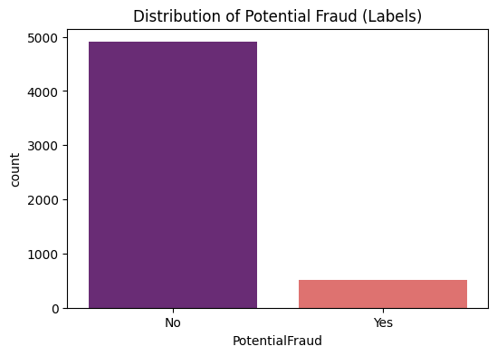
Figure 3.1: Distribution of Potential Frauds

Distribution of Claims
The reimbursement distribution (Figure 3.2) shows that inpatient claims range from ~5,000 to 120,000, with a peak around 10,000–15,000, while outpatient claims are mostly below 2,000. The study found that inpatient claims showed more diverse patterns of expenditures, which could serve as a tool for identifying medical providers who engaged in unorthodox practices.
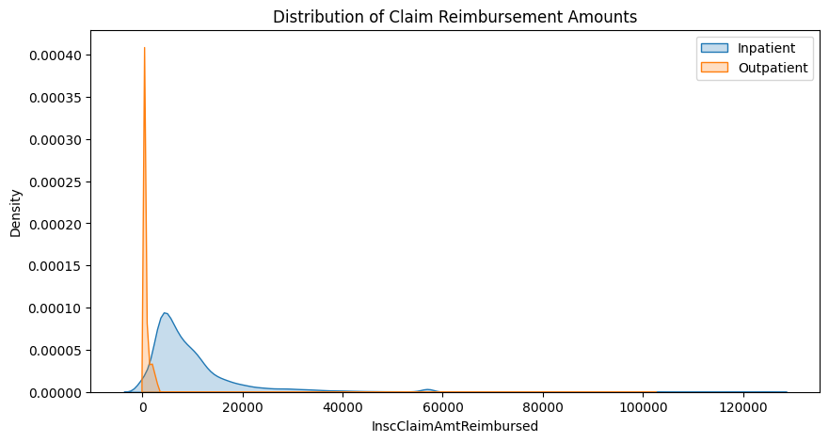
Figure 3.2: Distribution of Claims Reimbursements Amounts

Correlation Heatmap
The correlation heatmap display in Figure 3.3 demonstrates strong connections between different features. The two variables TotalReimbursement and TotalDeductible show a correlation coefficient of 0.96 while UniqueBeneficiaries and TotalClaims exhibit a correlation of 0.94. The relationship between fraud and TotalReimbursement shows moderate correlation at 0.58 and TotalDeductible shows a similar relationship at 0.53 which makes these two elements essential for detecting fraud.
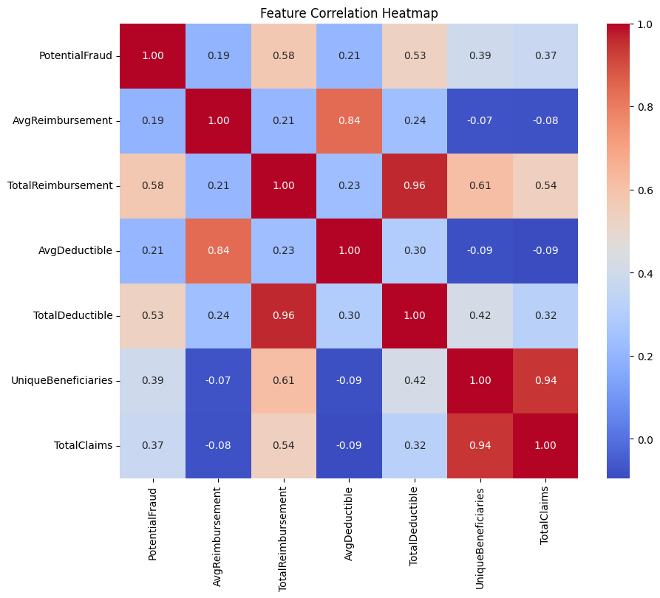
Figure 3.3: Correlation Heatmap

Feature Distribution Plot
The feature distribution plots (Figure 3.4) demonstrate that providers who commit fraud (1) tend to receive more TotalReimbursement which reaches a maximum of approximately 6 million dollars and they serve more beneficiaries which total around 3000 and they handle more claims which total approximately 8000 when we compare them to non-fraud providers (0). The relationship between beneficiaries and claims generates strong linear patterns which assist in identifying fraudulent activity.
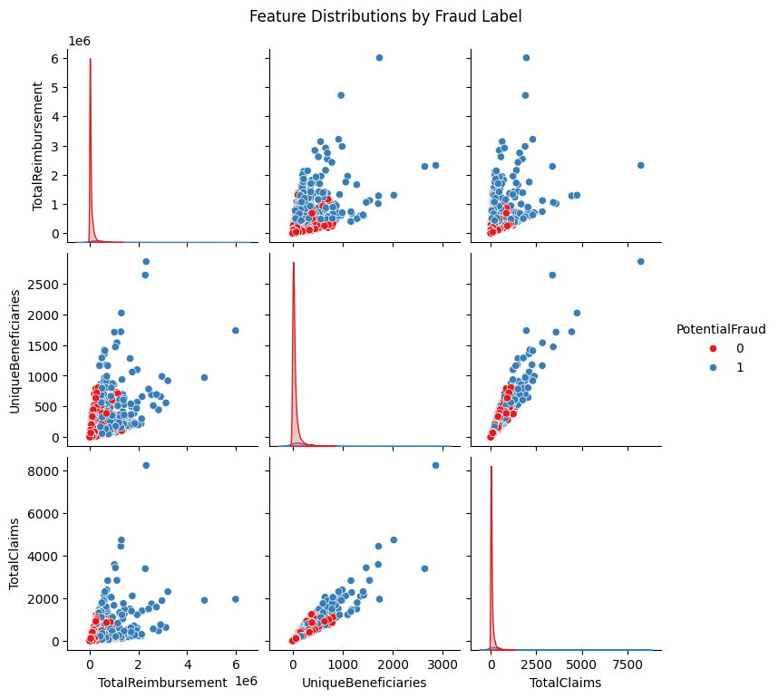
Figure 3.4: Feature Distribution Plot

Ethical Consideration

Overview
The research examines ethical problems that arise from healthcare claims data because of issues concerning privacy and consent and licensing and responsible data handling.

Data Privacy and GDPR
The dataset is anonymised and does not contain personally identifiable information. The system employs encoded Provider and Beneficiary IDs to protect user privacy while maintaining essential identification functions. The data originates from the United States therefore GDPR regulations do not apply yet the organization implemented ethical data management methods.

Ethical Approval
The study did not require ethical approval because it used publicly available secondary data without involving human subjects or data collection.

Permission and Licensing
The dataset is licensed under CC BY 4.0 (Liang, 2024) which permits free academic use of the material as long as users provide proper attribution.

Ethical Use
The data was used responsibly for research purposes only which ensured that no re-identification of information would occur and no unauthorized use of data would happen.

Methodology

Overview
During my study, I used a systematic machine learning process to identify fake healthcare providers based on aggregated claims information. The methodology entails data division, model creation, class imbalance, model testing, validation and explainable artificial intelligence to guarantee correct, effective, and comprehendible fraud detection.

Train-Test Split
I split the dataset into training (80 percent) and testing (20 percent) sets in my research through stratified sampling. This was done to make sure that the distribution of the fraudulent and non-fraudulent providers was unequal in both sets, it is necessary because the dataset was unequal.

Machine Learning Models
I have picked three of the supervised ensemble learning models in my research because of their use with structured healthcare data:
Random Forest (RF):
I have applied Rand Forest since it minimizes overfitting by making a combination of several decision trees. It is able to model multifaceted non-linear relationships and resistant to noise in health insurance claims data.
XGBoost (Extreme Gradient Boosting):
I have chosen XGBoost because of its excellent results in classification tasks. It employs gradient boosting including regularization that enhances accuracy and overfitting.
LightGBM (LGBM):
However, I tested LightGBM since it is computationally effective and can be used when dealing with large amounts of data. Its tree-growing leaf-wise makes it more precise than the conventional techniques of boosting.

Preliminary Model Specification
I used the basic model configurations at initial for training the model as shown in the Table 5.1.
Table 5.1: Key parameters used in training
Model | Key Parameters Used
Random Forest | n_estimators=100, random_state=42
XGBoost | random_state=42, eval_metric='logloss'
LightGBM | random_state=42

Handling Class Imbalance
I experienced a high level of class imbalance (9:1) in my study. In order to deal with that, I used SMOTE (Synthetic Minority Over-sampling Technique) on the training data. This approach produces artificial specimens of the minority category (fraud) to enable the model to gain more understanding about fraud patterns.

Model Evaluation
To ensure a fair judgment on the performance of the fraud detection, model evaluation was conducted in my research following the application of SMOTE.
I assessed the models based on the following measures:
- Accuracy: It is the general accuracy of predictions.
$$Accuracy=\frac{TP+TN}{TP+TN+FP+FN}$$
- Precision: Shows the number of frauds that are predicted to be fraudulent.
$$Precision=\frac{TP}{TP+FP}$$
- Recall (Sensitivity): Determines capacity to detect fraudulent provider correctly.
$$Recall=\frac{TP}{TP+FN}$$
- F1-Score: Precision divided by recall (and vice versa) that are significant in case of imbalance of data.
$$F1-Score=2 X \frac{Precision X Recall}{Precision+ Recall}$$
- ROC-AUC: This is a measure of the capacity of the model to differentiate between the classes of fraud and non-fraud.
$$\int_{0}^{1}{TPR\left({FPR}^{-1}\left(x\right)\right)dx}$$
Visual evaluation was also done using confusion matrices and ROC curves.

Model Comparison
I used Random Forest, XGBoost, and LightGBM in my study and compared them using their performance metrics after class balancing. Recall and F1-score were given special attention, because it is more important to detect the fraudulent providers rather than the general accuracy.

Cross-Validation
I used Stratified 5-Fold Cross-Validation in my study to measure the stability and generalizability of a model.
In this approach, the data is split into five equal components without changing the distribution of classes. The training and testing fold are four and one respectively in every iteration. This is done five times such that the fold is a test set in one instance.
Final performance is found by averaging and standard deviation of evaluation performance (Accuracy, Precision, Recall and F1-score). A small standard deviation would mean that the model is consistent across a variety of data splits and is reliable.

Explainable AI (SHAP)
SHAP (SHapley Additive exPlanations) was the tool that I applied because I needed to explain model predictions in my study.
Global interpretation: Determines the most significant characteristics that determine fraud detection.
Local Interpretation: This explains individual predictions through the demonstration of how each of the features leads to the decision.
This assists in making the model more transparent and not a black box as it is necessary in the context of healthcare.

Tools and Libraries
The tools and libraries I used in my research were the following:
- Python for implementation
- Numpy, data processing Pandas.
- Visualization Matplotlib, Seaborn data visualization.
- scikit-learn Train models, evaluate and cross-validate models.
- Advanced boosting models use XGBoost and LightGBM.
- Imbalanced-learn (SMOTE) to deal with class imbalance.
- SHAP to explainable AI and model interpretation.
These tools helped to conduct an effective analysis of the data, model building, and interpretation during the research.

Results

Overview
My research involved testing different machine learning models through the use of Accuracy, Precision, Recall, F1-score, and ROC-AUC metrics. The dataset imbalanced nature required me to give greater weight to Recall and F1-score because these metrics better assess the system's capability to find fraudulent providers.

Performance Before Balancing Strategies
The performance of models before applying SMOTE is shown in Table 6.1.
Table 6.1: Model Performance before Balancing Strategies
Model | Accuracy | Precision | Recall | F1-Score | ROC-AUC
Random Forest | 0.9344 | 0.6786 | 0.5644 | 0.6162 | 0.9398
XGBoost | 0.9316 | 0.6709 | 0.5248 | 0.5889 | 0.9372
LightGBM | 0.9390 | 0.7273 | 0.5545 | 0.6292 | 0.9477
The first data set shows that all models achieved accuracy benchmarks which exceeded 93 percent before balancing process. The dataset demonstrates severe imbalances which cause accuracy measurements to produce incorrect results.
- LightGBM achieved the highest F1-score (0.6292) which showed it performed best because its precision and recall metrics reached an optimal balance.
- Random Forest achieved slightly higher recall (0.5644) compared to LightGBM (0.5545).
- XGBoost performed the weakest in recall (0.5248), meaning it missed more fraud cases.
The relatively low recall values (0.52–0.56) indicate that a significant number of fraudulent providers were not detected.
The F1-score and Recall results from all models appear in Figure 6.1. The results show that F1-scores reach moderate levels between 0.58 and 0.63 while the recall values stay below that level, which indicates that the models face challenges when trying to identify fraud in data with unequal class distribution.
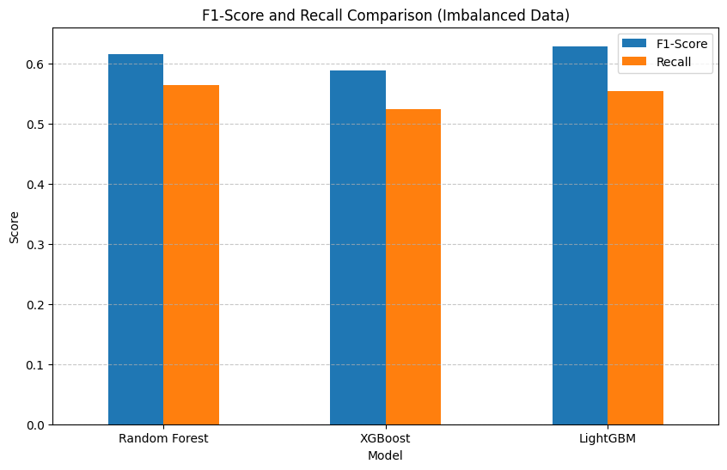
Figure 6.1: F1-Score and Recall Comparison

Performance After Balancing Strategies (SMOTE)
After applying SMOTE, the results improved significantly, as shown in Table 6.2.
Table 6.2: Performance after balancing
Model (SMOTE) | Accuracy | Precision | Recall | F1-Score | ROC-AUC
Random Forest | 0.8965 | 0.4671 | 0.7723 | 0.5821 | 0.9322
XGBoost | 0.8909 | 0.4472 | 0.7129 | 0.5496 | 0.9280
LightGBM | 0.8900 | 0.4483 | 0.7723 | 0.5673 | 0.9316
After balancing, recall increased significantly across all models: Random Forest (0.5644→0.7723), XGBoost (0.5248→0.7129), and LightGBM (0.5545→0.7723). Random Forest and LightGBM achieved the highest recall, correctly identifying about 77% of fraud cases. The models dedicated themselves to fraud detection, which caused F1-score and accuracy to decrease. Figure 6.2 shows this improvement in recall, confirming that SMOTE enhances fraud detection performance.
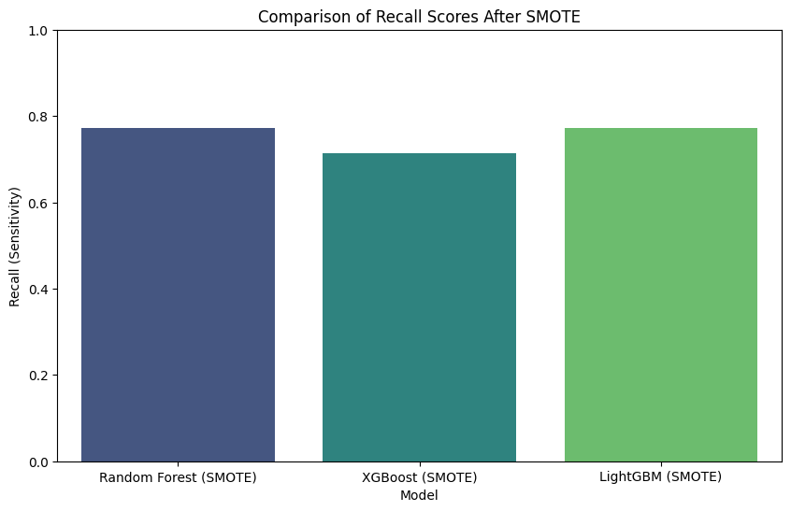
Figure 6.2: Comparison of Recall after SMOTE

Visualization of Models
LightGBM (Figure 6.3) correctly classifies most non-fraud cases (960) but misses many fraud cases (45), showing imbalance and lower fraud detection performance.
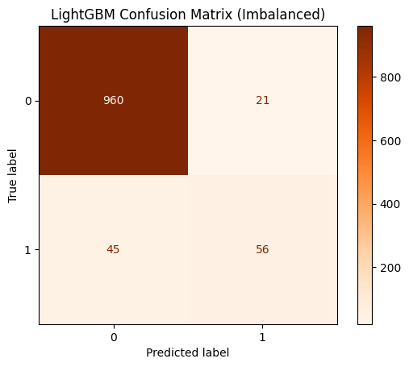
Figure 6.3: Confusion Matrix of LightGBM
Figure 6.4 shows that all models performing well with high AUC values (RF = 0.94, XGB = 0.94, LGBM = 0.95). LightGBM slightly outperforms other models. The curves show high performance in detecting fraud and non-fraud cases because AUC results show limitations in recalling imbalanced data.
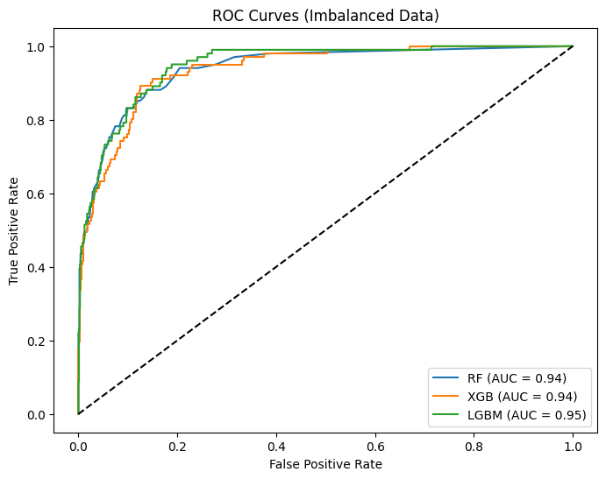
Figure 6.4: The ROC curves

Cross-Validation Results
To evaluate model stability, I applied Stratified 5-Fold Cross-Validation as shown in Table 6.3.
Table 6.3: K-Fold Cross Validation
Model (SMOTE) | Accuracy (Mean ± Std) | Precision (Mean ± Std) | Recall (Mean ± Std) | F1-Score (Mean ± Std)
Random Forest | 0.9335 ± 0.0042 | 0.9196 ± 0.0060 | 0.9500 ± 0.0053 | 0.9346 ± 0.0041
XGBoost | 0.9324 ± 0.0088 | 0.9209 ± 0.0066 | 0.9462 ± 0.0152 | 0.9333 ± 0.0091
LightGBM | 0.9285 ± 0.0038 | 0.9154 ± 0.0080 | 0.9444 ± 0.0041 | 0.9296 ± 0.0034
Interpretation:
All models show strong and stable performance with low standard deviation. Random Forest achieved the highest F1-score and recall, indicating consistent performance across folds.

Model Interpretability using XAI
The SHAP bar plot (Figure 6.5) establishes feature importance rankings through Its presentation of data. The TotalReimbursement variable shows the greatest effect on outcomes while TotalClaims follows as the next most important element. The other features demonstrate insufficient influence which shows that reimbursement-related variables remain the primary factors that drive fraud prediction results.
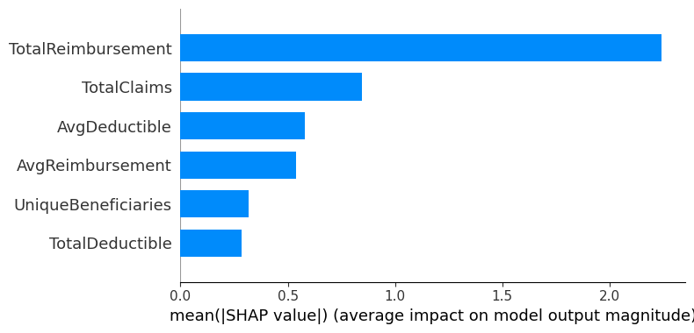
Figure 6.5: SHAP bar plot
The SHAP summary plot (Figure 6.6) shows how feature values influence predictions. The model shows higher fraud likelihood with increasing TotalReimbursement and TotalClaims but it predicts non-fraud when these values decrease.
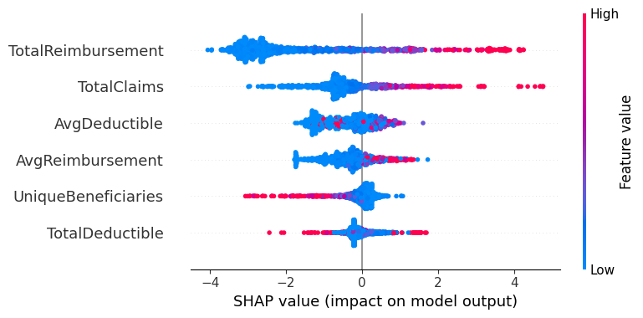
Figure 6.6: SHAP summary Plot
The SHAP force plot (Figure 6.7) explains a single prediction. The model shows high fraud probability because TotalReimbursement and TotalClaims reach high values while other features show lower values.
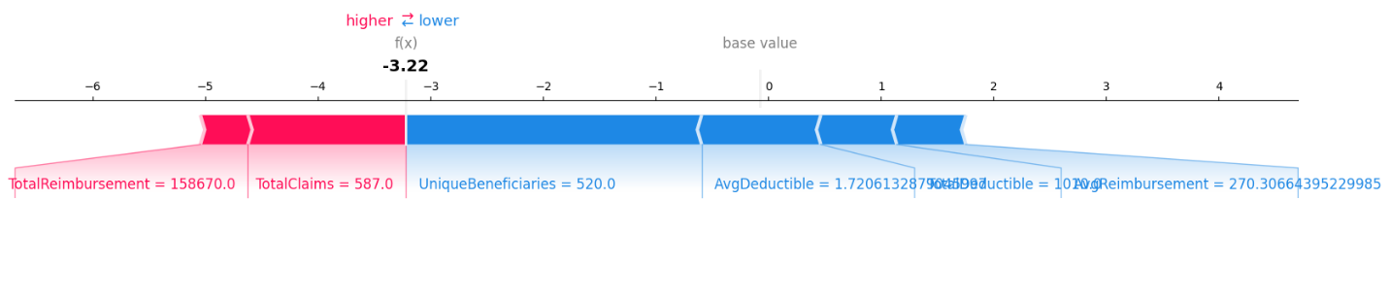
Figure 6.7: SHAP force plot

Research Questions Addressed
The research I conducted provides complete answers to all research questions.
- RQ1: The highest F1-score before applying SMOTE to LightGBM reached 0.6292. The Random Forest model demonstrated its best performance after achieving balanced data because it delivered high recall results of 0.7723 and maintained consistent F1-score values.
- RQ2: SHAP analysis identified TotalReimbursement and TotalClaims as the most influential features. Fraud detection relies on these two features because their increased values create a direct relationship with higher fraud detection possibilities.
- RQ3: The application of SMOTE technology brought about total recall improvements for every model which includes Random Forest because the method elevated detection capabilities for minority fraud situations.

Practical Applicability
The research findings demonstrate their strong applicability to real-world healthcare systems.
- The developed model can be integrated into health insurance systems to automatically flag suspicious providers.
- High recall ensures that most fraudulent cases are detected, reducing financial losses.
- Through SHAP-based explanations the system provides transparent insights which allow auditors and investigators to understand the reasons behind provider flagging.
- The system can support decision-making for fraud investigation, improving efficiency and reducing manual effort.

Analysis and Discussion

Overview
This chapter will be an analysis of the findings contained in Chapter 6 and how they are relevant to the research objectives and research questions. It assesses the performance of the models, delivers a discussion on the influence of the class imbalance, and then compares the research with the existing literature, as well as presenting the practical implications and restrictions of the suggested approach.

Interpretation of Results
The findings indicate that the accuracy is not a good measure when analyzing the fraud detection models in the imbalanced datasets. Even though all models obtained high accuracy scores of above 93 percent prior to using SMOTE, this is primarily because of the correct classification of non-fraud cases prior to using SMOTE since the class imbalance indicated in Figure 3.1 is high.
The Recall and F1-score measure which are more meaningful evaluation metrics give a clearer picture of how the model works. The value of recall before balancing was between 0.5248 and 0.5644 which means that a big number of fraudulent providers was undetected. This is a serious concern since fraud occurs without detection hence causing losses of money and low reliability of the system.
Recall was an improvement in all models after the use of SMOTE. Random Forest recall rose by 0.5644 to 0.7723, XGBoost rose by 0.5248 to 0.7129 and LightGBM rose by 0.5545 to 0.7723. This shows that the balancing methods enable models to learn more about fraud-related patterns.
Meanwhile, the accuracy dropped by about 93 percent to 89 percent, and the precision was lower. Nevertheless, this trade-off is agreeable since the model is able to detect fraud more efficiently as compared to targeting the majority class. The reduction in the F1-score was a slight decrease because of reduced precision, but it did not affect the balance of performance.
The values of ROC-AUC were steady and ranged between 0.93 and 0.95 across all models, which demonstrate high abilities of differentiating between the classes of fraud and non-fraud. Nevertheless, the effectiveness in the detection of minority fraud cases is not entirely reflected by ROC-AUC, which supports the significance of recall in the current research.

Effect of Class Imbalance and SMOTE.
These findings prove the fact that the class imbalance is a significant factor influencing the model performance. Models without balancing will tend to prediction of non-fraud cases. This is because the use of SMOTE enhances the sensitivity of the model since it produces artificial frauds thus enabling the learning of the minority class patterns.
The significant increase in the recall on the application of SMOTE can justify that balancing techniques are necessary in detecting fraud and directly confirm the research objective to the enhancement of minority fraud cases detection.

Best Performing Model
Random Forest with SMOTE was the most overall performing in all models. Although LightGBM had the highest F1-score uncapped, balancing was achieved by the Random forest, which had the best balance between recall and F1-score.
The reason behind this is that random forest lowers overfitting by bagging and it is also more enduring with respect to noise and imbalance of data. Conversely, enhancement of models like XGBoost and LightGBM are more likely to concentrate on prevailing patterns, which restricts their usefulness in unbalanced information devoid of balancing methods.

Comparison with Literature
The findings are in line with the past research talked about in Chapter 2, Chaurasiya & Jain and Nabrawi & Alanazinoted that the Random Forest has a good performance in fraud detection, whereas Chaurasiya & Jain (2025) reported the success of ensemble models.
This study, however, is better than the current literature since it is supplemented by SHAP-based explainability, which is missing in the previous literature. Also, aggregated provider-level features can be used, which is a feasible way of detecting fraud in practice.

Importance and Explainability of Features.
The most significant features affecting the fraud detection were TotalReimbursement and TotalClaims according to SHAP analysis. These characteristics are financial and operational conduct, which are major pointers of fraud.
The stronger the values of these features, the higher chances there are that the cases are fraud and the lower the values, the higher are the possibilities that the cases are not fraud. SHAP is better to enhance transparency and enable decision-makers to interpret model predictions.

Limitations of the Study
Though it is performing well, there are a number of limitations. The database is founded on aggregated claims data and fails to reflect minute transactional or time-patterns. The application of SMOTE provides artificial data that might not be entirely relevant to actual cases of fraud. Also, there were only three models tested and hyperparameter tuning was also restricted.

Relation to Research Objectives and Research Questions.
The findings answer all questions used to conduct the research. Comparison of F1-score and recall was used to determine the best-performing model. SHAP was used to identify important features associated with frauds. The usefulness of SMOTE in enhancing recall was well showed.

Practical Applicability
The models developed can be implemented within the healthcare system in the real world to identify the fraud providers. A high recall assures that the majority of frauds are detected, whereas as explainable AI offers transparency to auditors. The strategy can facilitate automatic frauds detection applications and enhance decision making.

Conclusion
The research proved that machine learning models succeed in identifying fraudulent healthcare providers through their analysis of combined claims information. The results showed that traditional evaluation metrics such as accuracy are not sufficient for imbalanced datasets, while Recall and F1-score provide more meaningful insights. The Random Forest model which used SMOTE showed the best results among all tested models because it improved its ability to detect fraudulent activity. The SHAP analysis confirmed that Total Reimbursement and Total Claims are the essential features because they provide strong predictive ability and clear explanation.
The findings of this study have strong practical applications in real-world healthcare systems. The developed models can be integrated into insurance systems to automatically flag suspicious providers which helps organizations to enhance their operational processes and cut down on their financial losses. Future work can focus on incorporating temporal and patient-level data, applying deep learning models, and exploring cost-sensitive learning approaches. The development of advanced hyperparameter tuning and better feature engineering methods will lead to improved model performance which will help large-scale healthcare fraud detection systems to better handle various cases.

References
Chaurasiya, R., & Jain, K. (2025). HEALTHCARE FRAUD DETECTION USING MACHINE LEARNING ENSEMBLE METHODS: XXVI.
Chellappan, S., & Abuhalimeh, A. (2025). Machine learning techniques in healthcare provider fraud detection and analysis: A systematic literature review. AI Insights, 2025(1), 4612. https://doi.org/10.18282/aii4612
du Preez, A., Bhattacharya, S., Beling, P., & Bowen, E. (2025). Fraud detection in healthcare claims using machine learning: A systematic review. In Artificial Intelligence in Medicine (Vol. 160). Elsevier B.V. https://doi.org/10.1016/j.artmed.2024.103061
Hancock, J. T., Bauder, R. A., Wang, H., & Khoshgoftaar, T. M. (2023). Explainable machine learning models for Medicare fraud detection. Journal of Big Data, 10(1). https://doi.org/10.1186/s40537-023-00821-5
Johnson, J. M., & Khoshgoftaar, T. M. (2023). Data-Centric AI for Healthcare Fraud Detection. SN Computer Science, 4(4). https://doi.org/10.1007/s42979-023-01809-x
Matloob, I., Khan, S., Rukaiya, R., Alfrahi, H., & Ali Khan, J. (2025). Healthcare fraud detection using adaptive learning and deep learning techniques. Evolving Systems, 16(2). https://doi.org/10.1007/s12530-025-09698-6
Muhammad, R., Tbaishat, D., Nazir, A., Yacoub, S., AbdulRazek, M., El-Enen, M. A. A., & Sahlol, A. T. (2025). Fraud detection and explanation in medical claims using GNN architectures. Scientific Reports, 15(1). https://doi.org/10.1038/s41598-025-22910-6
Nabrawi, E., & Alanazi, A. (2023). Fraud Detection in Healthcare Insurance Claims Using Machine Learning. Risks, 11(9). https://doi.org/10.3390/risks11090160
Villegas-Ortega, J., Quiroz Aviles, L. N., Arancibia, J. N., Montenegro, W. C., Delgadillo, R., & Mauricio, D. (2025). Methodology for Detecting Suspicious Claims in Health Insurance Using Supervised Machine Learning. Future Internet, 17(12). https://doi.org/10.3390/fi17120584

Appendix
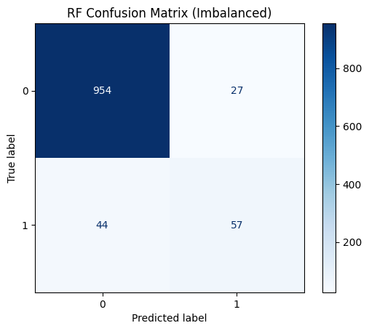

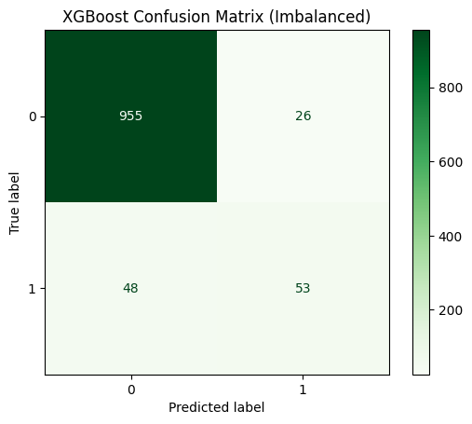
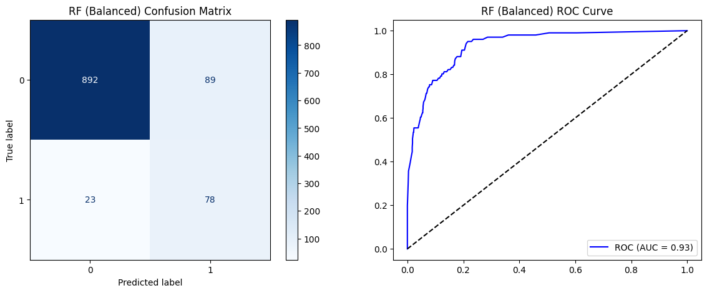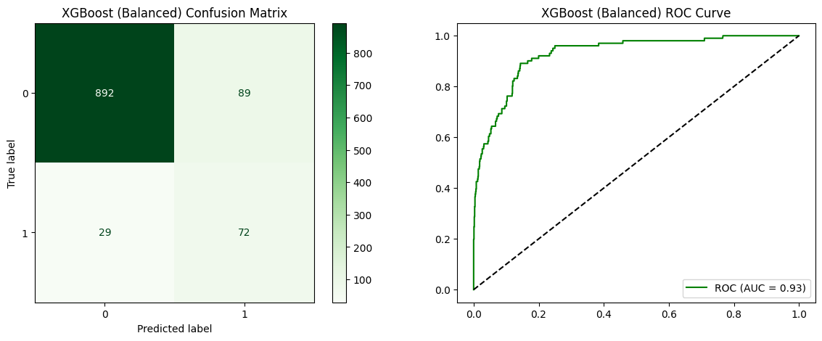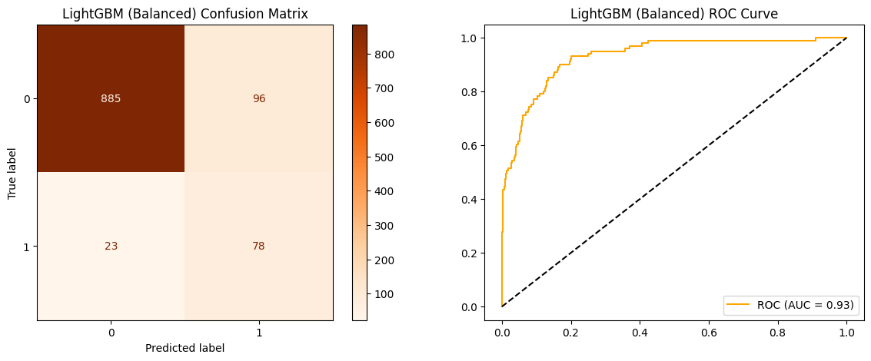

https://data.mendeley.com/datasets/gsn2hyty37/1

